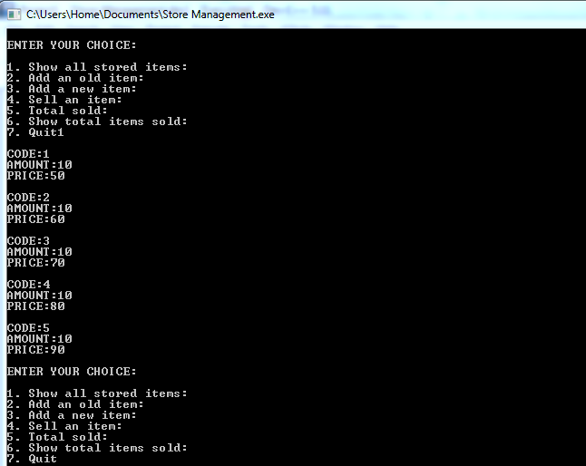

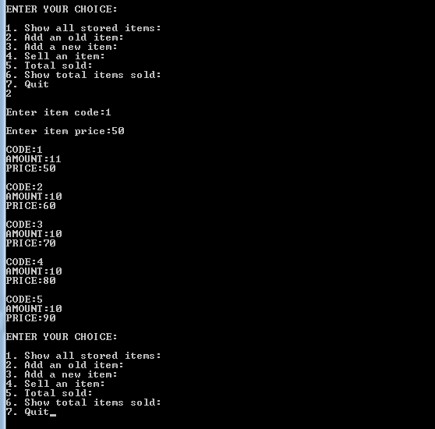

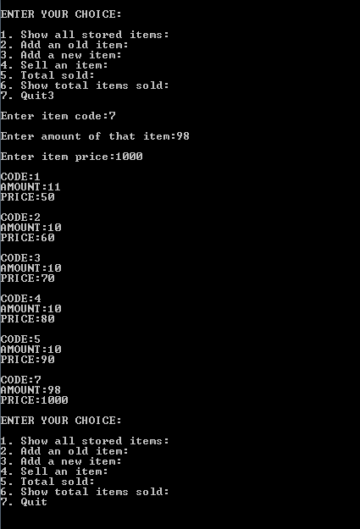

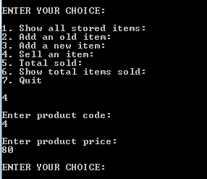

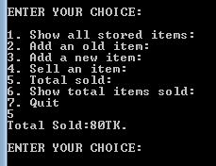

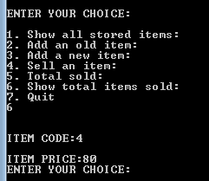

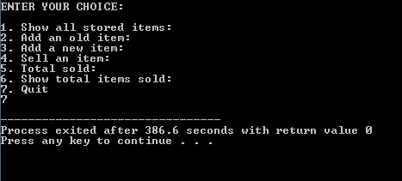

CODING

#include<iostream>

#include<conio.h>

using namespace std;

const int m=20;

class dept

{ int amount[m],pris[m],k,a,b,amount1;

int code,code1,cod[m],s,last;

public:

float price,price1;

dept(void);

void sell(void);

void total_items(void);

void add_old(void);

void add_new(void);

void show(void);

};

dept:: dept(void)

{ s=0;a=10;b=40;last=5;amount[0]=0;

for(int k=0;k<last;k++)

{ s=s+1;b=b+10;

cod[k]=s;

amount[k]=a;

pris[k]=b;

}

}

void dept::add_old(void)

{ cout<<"\nEnter item code:";

cin>>code1;

cout<<"\nEnter item price:";

cin>>price1;

for(k=0;k<last;k++)

{ if(code1==cod[k])

{ a=a+1;

amount[k]=a;

pris[k]=price1;

}

// else

//cout<<"\nSorry..This item is not available.\n";

}

}

void dept::add_new(void)

{ cout<<"\nEnter item code:";

cin>>code1;

cout<<"\nEnter amount of that item:";

cin>>amount1;

cout<<"\nEnter item price:";

cin>>price1;

cod[last]=code1;

amount[last]=amount1;

pris[last]=price1;

last++;

}

void dept::show(void)

{ for(k=0;k<last;k++)

{

cout<<"\nCODE:"<<cod[k]<<"\t";

cout<<"\nAMOUNT:"<<amount[k]<<"\t";

cout<<"\nPRICE:"<<pris[k]<<endl;

}

}

void dept::sell(void)

{

cout<<"\nEnter product code:\n";

cin>>code;

cout<<"\nEnter product price:\n";

cin>>price;

}

void dept::total_items(void)

{

cout<<"\n\nITEM CODE:"<<code<<"\n\nITEM PRICE:"<<price;

}

int main()

{

dept d[10];

static int j=0;

int x,i=0,p,s=0;

system("cls");

do{

cout<<"\nENTER YOUR CHOICE:\n";

cout<<"\n1. Show all stored items:";

cout<<"\n2. Add an old item:";

cout<<"\n3. Add a new item:";

cout<<"\n4. Sell an item:";

cout<<"\n5. Total sold:";

cout<<"\n6. Show total items sold:";

cout<<"\n7. Quit";

cin>>x;

switch(x)

{ case 1: d[i].show();

break;

case 2: d[i].add_old();

d[i].show();

break;

case 3: d[i].add_new();

d[i].show();

break;

case 4: d[i].sell();

i++,j++;

break;

case 5:{ cout<<"Total Sold:";

s=0;

for(p=0;p<j;p++)

{ s=s+d[p].price;

}

cout<<s;

cout<<"TK.\n";

}

break;

case 6: for(i=0;i<j;i++)

{ d[i].total_items();

}

break;

case 7: break;

}

} while(x!=7);

getch();

return 0;

}